
Company
Logotype

Cone Beam Computed Tomography- Report



Porur Dental X-rays & CBCT

Patient Name : Mr. Venkatesh | Date of Report : 15.03.2024
Age/ Gender : 38 years/ Male | Region of Interest : CBCT Sectional Mandible
Referring doctor: Dr. Narmadha | Indication : Assessment of 47
Clinical Notes: Nil
PATIENT INFORMATION

CBCT- Sectional Mandible provided
CBCT – IMAGE DETAILS

RADIOGRAPHIC INTERPRETATION

- In relation to 47, hyperdense restorative material involving the crown and extending into the root canal upto the apical third is evident.
- Below the coronal restoration of 47, a small area of hypodensity evident suggestive of lack of restorative material.
- The alveolar bone in relation to 46, 47 is present with normal trabecular pattern.

RADIOGRAPHIC IMPRESSION

- Root canal treated tooth: 47

Kindly correlate with clinical findings


IMAGES FOR REFERENCE

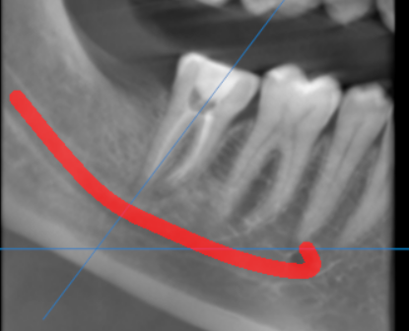

3-DIMENSIONAL VIEW

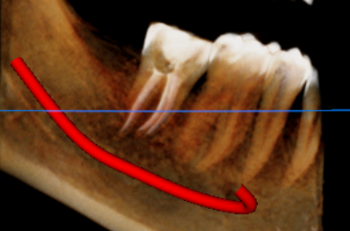

CROSS SECTIONAL VIEW

47 region | 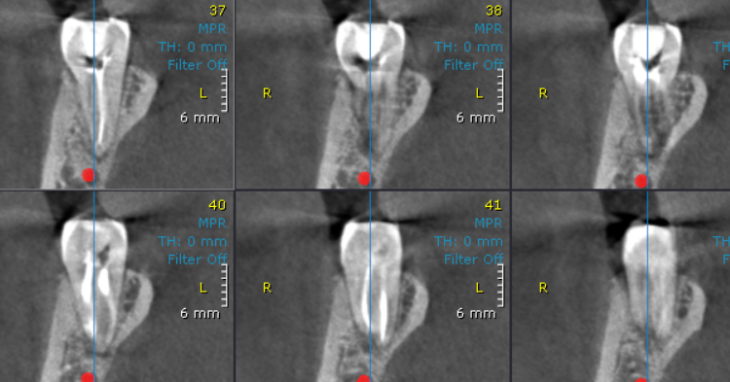

**** End of report ****

